Practical-04

C Program:

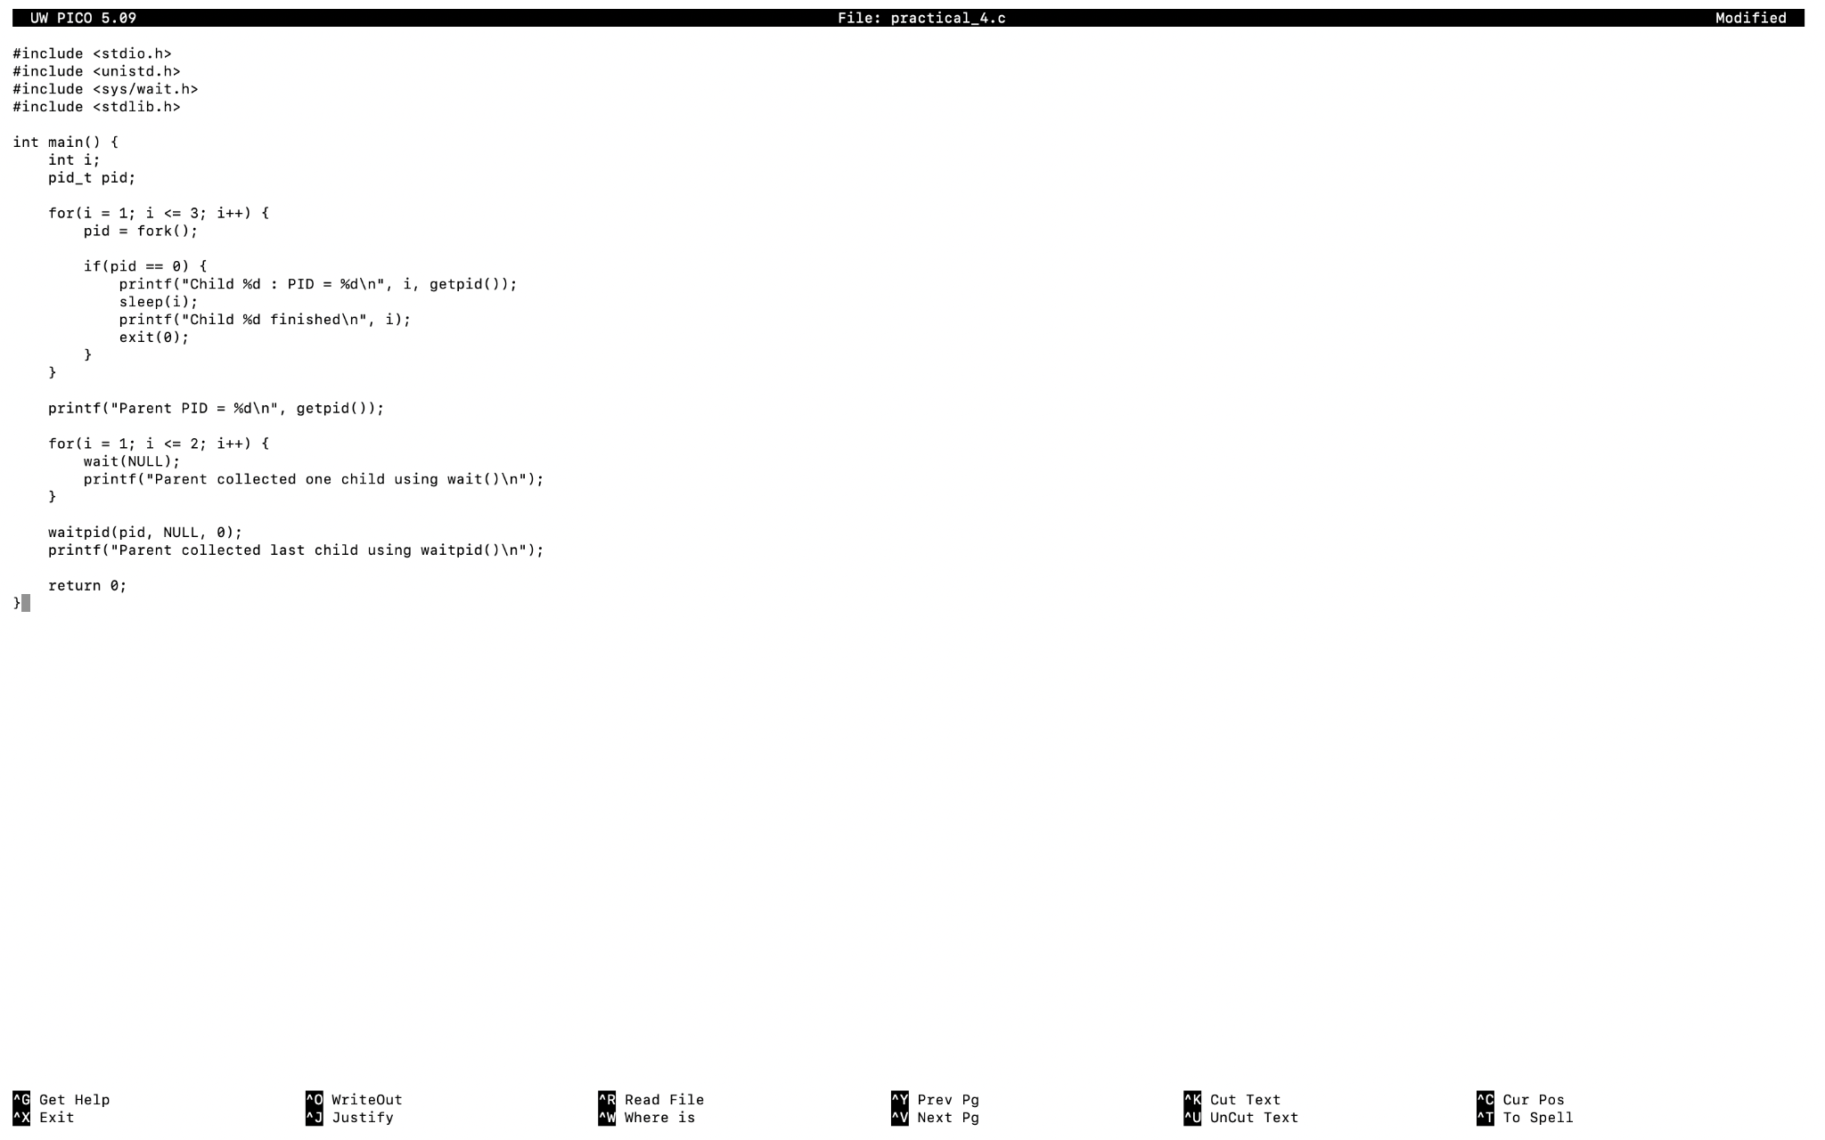

Output:
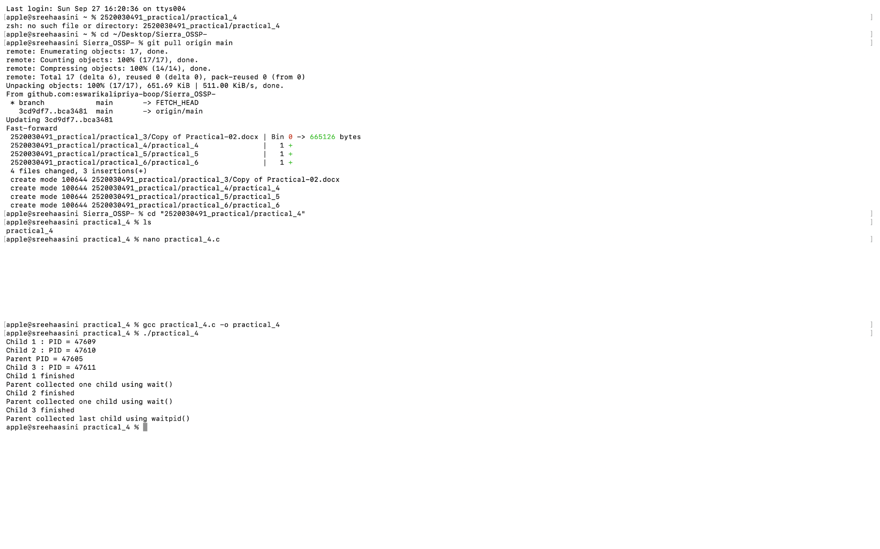

zombie 1 :
code
#include <stdio.h>
#include <unistd.h>
#include <stdlib.h>

int main() {
pid_t pid = fork();

if(pid == 0) {
printf("Child Process PID: %d\n", getpid());
printf("Child exiting...\n");
exit(0);
}
else {
printf("Parent PID: %d\n", getpid());
printf("Sleeping for 30 seconds...\n");
sleep(30);
printf("Parent exiting\n");
}

return 0;
}

Output:

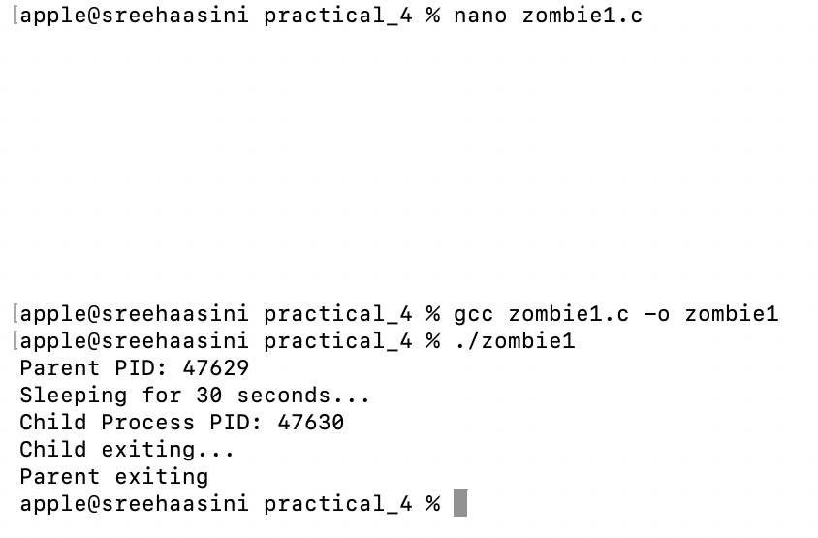

zombie 2 :
code
#include <stdio.h>
#include <unistd.h>
#include <sys/wait.h>
#include <stdlib.h>

int main() {
pid_t pid = fork();

if(pid == 0) {
printf("Child PID: %d\n", getpid());
exit(0);
}
else {
printf("Parent waiting...\n");
wait(NULL);
printf("Zombie removed. Child collected.\n");
}

return 0;
}

Output:
